# Tableau Desktop Specialist Training

## Week One – Monday (6/21/2021)

### Introductions

Who are you?

Who, who, who, who?

Hobbies?

Aspirations?

Something different?

Why this class?

If you were independently wealthy, then what would you do with the rest of your life?

### Objectives

Tableau is an interactive data visualization tool which is used to visualize big data and business intelligence. Tableau creates a wide range of visuals to interact and represent the demonstrative data. It showcases the data in such a way that can be easily understood without going through the facts.

* Tableau helps to see and understand the data by transforming them into visual dashboards. Tableau analyses the data and showcases them beautifully to the users.
* Tableau is programmed to suit different types of suits and organization. Big or small, technical or non-technical; Tableau works for every type of company.
* The program is a killer in creating data visuals easily and quickly.
* You can easily connect Tableau with different data sources and continue working on your favorite apps.
* Tableau works on simple calculations and data. No coding is involved in using the software effectively.
* You do not need to do anything except entering the data. Tableau automatically connects with the data, reads it and creates visual reports.
* Tableau users find the program genuine and are happy to use them in the everyday business analysis. It helps them to plan strategies and implement them in development of the business.

### Tableau Desktop Certification

Tableau Certification allows you to stand out against competition and validate your in-demand skills for your desired industry. Start paving the way to your future and boost your resume with in-demand data analytics expertise.

<https://www.tableau.com/learn/certification>

There are many ways to prepare for the exam that can take up to 3 months or more. I am very happy that you all chose not just to prepare for an exam, but to prepare for a challenging career in Business Intelligence. However, this class alone will only get you so far with the exam. I highly recommend taking advantage of all the FREE resources provided by Tableau and other companies.

Captain Obvious – The prep guide that gives and outline of the skills and some sample questions.

[https://mkt.tableau.com/files/DesktopSpecialist_ExamGuide.pdf?_gl=1*m12r15*_ga*MTQ1MDE1ODk5My4xNjE3MDQwMzEx*_ga_8YLN0SNXVS*MTYyMjc1MTE4OC4xMS4xLjE2MjI3NTI0MzYuMA](https://mkt.tableau.com/files/DesktopSpecialist_ExamGuide.pdf?_gl=1*m12r15*_ga*MTQ1MDE1ODk5My4xNjE3MDQwMzEx*_ga_8YLN0SNXVS*MTYyMjc1MTE4OC4xMS4xLjE2MjI3NTI0MzYuMA)..

This link will provide free videos to complement what we are doing in class - <https://www.tableau.com/learn/training/20211>. Be sure to focus on those under “Creator”!

There are many free practice exam questions, which we will cover a few on Thursday nights as part of class. However, feel free to go out on your own and explore any others except for the following:

<https://www.analyticsexam.com/sample-questions/tableau-desktop-specialist-certification-exam-sample-questions>

<https://www.simplilearn.com/tableau-exam-questions-free-practice-test>

You will bolster my ego if everyone gets 100% on both practice tests!

There is also a wonderful forum for getting questions answered. I cannot even imagine how I would have gotten up to speed with Tableau if it were not for this resource - [https://community.tableau.com/s/explore-forums?_gl=1*1hrpt5a*_ga*MTQ1MDE1ODk5My4xNjE3MDQwMzEx*_ga_8YLN0SNXVS*MTYyMjc1MTE4OC4xMS4xLjE2MjI3NTE2MDcuMA..&_ga=2.219812249.1077079969.1622655150-1450158993.1617040311](https://community.tableau.com/s/explore-forums?_gl=1*1hrpt5a*_ga*MTQ1MDE1ODk5My4xNjE3MDQwMzEx*_ga_8YLN0SNXVS*MTYyMjc1MTE4OC4xMS4xLjE2MjI3NTE2MDcuMA..&_ga=2.219812249.1077079969.1622655150-1450158993.1617040311)

This is one you will use for the rest of your Business Intelligence career.

## Exam Format

**Time Limit:** 60 minutes

**Question Format:** Multiple choice, multiple response, hands-on

**Number of Questions:** 30

**Scoring:** Automatically scored; point value varies per question type with hands-on worth more

**Passing Score:** 70%

**Language(s) Offered:** English, Japanese, Simplified Chinese, German, French, Brazilian Portuguese, International Spanish

**Delivery Platform:** Windows Virtual Machine containing Tableau Desktop

## System Preparation

### For a successful exam experience, ensure your computer, network, and the physical environment are properly configured. This includes running a system & network tech-check before the exam.

### Review our Exam Setup Guide for complete details ([https://mkt.tableau.com/files/Tableau-Certification-4-steps-to-exam-success.pdf?_gl=1*fu0lco*_ga*MTQ1MDE1ODk5My4xNjE3MDQwMzEx*_ga_8YLN0SNXVS*MTYyMjc3MTA3MS4xMi4xLjE2MjI3NzEzOTcuMA](https://mkt.tableau.com/files/Tableau-Certification-4-steps-to-exam-success.pdf?_gl=1*fu0lco*_ga*MTQ1MDE1ODk5My4xNjE3MDQwMzEx*_ga_8YLN0SNXVS*MTYyMjc3MTA3MS4xMi4xLjE2MjI3NzEzOTcuMA)..).

### Classroom Required Software

* Tableau Public
* Microsoft Excel or Google Sheets
* Microsoft PowerPoint or Google Slides

NOTE: Students will need to have the Statistics add-on for either Excel or Sheets for use in performing forecasting and other types of data analysis.

### Tableau Public

1. Create a profile on Tableau Public - <https://public.tableau.com/en-us/s/>
   1. Sign Up with Name, Email, Password
   2. Profile – Add a Picture
   3. Settings/Defaults – Viz Toolbar: Allow viz data to be downloaded (check the box)
   4. Settings/Defaults – When Saving: Set my vizes to be hidden (check the box)
2. Download Tableau Public to your desktop - https://public.tableau.com/en-us/s/

This will get you started, but once you have adjusted the setting it will now be time to create your first viz… PLEASE don’t go overboard as we will go over all of this in the first class to get everybody comfortable with Tableau Public.

### Benefits

### Analytical reasoning is the #3 most-needed hard skill in 2020, according to LinkedIn. Start paving the way to your future and boost your resume with in-demand data expertise.

### **1. Tableau Experts are in high demand:**

As compared to the past nine to ten years, enterprises now generate a notable amount of data, which is approximately 60 times greater than what was being generated back then. Hence, enterprises around the globe require a tool that is not just user-friendly but also analyzes information by developing functional and actionable insights from it. Various visualization tools are available in the market today. But Tableau is hugely favored because it does the process quicker and is more accurate. Hence, it is the best time to get a certification in Tableau as well as build a career in Tableau and Data Visualization.

### **2. Help your organization grow:**

With the help of Tableau, non-technical people can now understand data and make data-driven decisions for the growth of their organizations.

### **3. Professionals can opt for varied roles:**

Technologies such as Business Intelligence, Artificial Intelligence, Machine Learning, Big Data, Cloud Computing, Deep Learning, Internet of Things (IoT), are spreading over to various industries and are expected to grow even more in the future. These developments have raised and will continue to give rise to various roles like:

* Tableau Consultant
* Data Analyst
* Data Strategist
* Data Visualization Analyst
* Business Intelligence Developer

### **4. Tableau Professionals have a bright future:**

Tableau aids businesses as they help them execute plans as well as compete with competitors. Professionals can understand and calculate the growing trend by studying the market. As a Tableau professional, you can plan strategies by just looking at the visual display on the dashboard and help companies have a bright future by doing so.

### Lesson One – Story Telling

Just like telling a story around the campfire, at a party, or at an informal gathering, the “art” requires creativity, vision, skill, and a bit of practice on delivery. Telling a story that displays opportunity, convincing the audience of the importance, taking action to capture as much of the opportunity as possible, illustrating the results and forecasting what will happen next involves the same techniques!

If you cannot present opportunity that is interesting/important it will be either an awfully long or extremely short presentation to senior management – Take it from my experience.

**Tell me a story!**

#### Homework

LinkedIn – Please do a search on the following under the “Jobs” tab:

Data Analyst, Data Visualization Analyst, and Business Intelligence Developer

United States, Missouri, Greater St. Louis, and Other states of interest!

Filters – Experience (Entry Level, Associate), Posted Past Week, Full-time How many jobs?

Look at the responsibilities and the specific qualifications around technologies. **DO NOT** be discouraged by the requirement of a bachelor’s degree or 2+ years’ experience as the certification is going to take the place of that for an intelligent Human Resource Manager and Hiring Manager.

Remember, the job posting is the IDEAL candidate… How many of those people are out there?

What parts of the country have the majority of jobs?

What is the attraction to those areas?

What about remote work in this day and age?

Final search for the day/night – Tableau Desktop Specialist How many jobs?

## Week One – Tuesday (6/22/2021)

### Discuss Homework Assignment

The future is so bright you gotta wear shades!



### Lesson One – Data Mining/Analytics Methodology

Let’s see about adding to your repertoire of storytelling apparatus.

The Cross Industry Standard Process for Data Mining (CRISP-DM) is a well-known industry standard that has stood the test of time for putting together valuable insights from an opportunity presented in a business setting with a vast wealth of information. Slide – CRISP-DM Diagram.

The CRISP-DM standard is comprised of six major phases, from which we will use a slight variation as follows:

* Business Relevance
* Data Understanding
* Data Preparation
* Modeling / Data Analytics
* Evaluation
* Deployment

We are not going to delve into building statistical models, but instead we are going to study the finer techniques of data analytics to drive out actionable insights.

There are several exceptionally good reference websites for review at your leisure:

<https://www.datascience-pm.com/crisp-dm-2/>

<https://agilethought.com/blogs/scaling-data-science-use-crisp-dm-agile/>

<https://towardsdatascience.com/why-using-crisp-dm-will-make-you-a-better-data-scientist-66efe5b72686>

This chart gives a sense of the steps within each phase, deliverables and a view that connects the flow of work to produce results that meet/exceed a customer’s expectations.

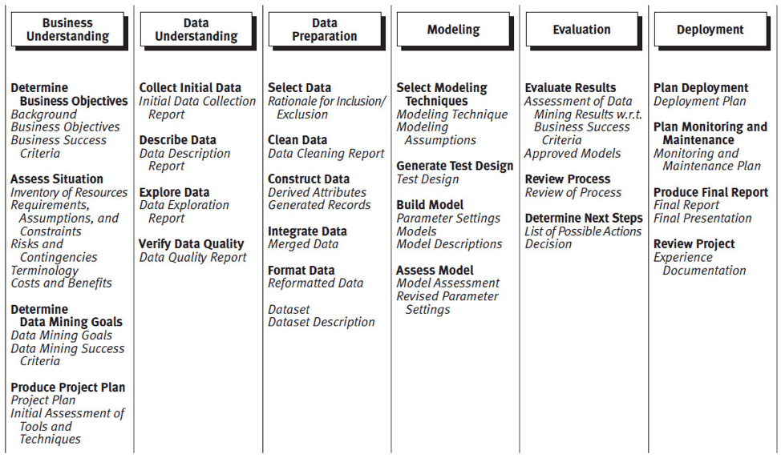

The substitution of Data Analytics or Modeling looks as follows:

**Story Telling**

*Define Opportunity*

*Determine Analysis to Act*

*Enticement with Results*

*Forecast “What If”*

*Compare to “What Was”*

**Data Visualization Methods**

*Construct Charts/Graphs to Illustrate Story*

*Annotation that Breathes Life*

*Is the Story a Best Seller?*

**Assess Results**

*Alternative Approach to Results*

*Cross Reference Results at Various Dimensions*

*Articulate Confidence in Results*

#### Activities

* Take a stab at conducting an interview to determine the Business Understanding/Relevance.
  + Here are a few tips for gathering the requirements – <https://www.phase2technology.com/blog/successful-requirements-gathering>.
  + How do these compare with an Agile or Lean approach for gathering requirements?
    - Lean article - <https://www.todaysoftmag.com/article/851/requirements-engineering-using-the-lean-methodology> (8 min read)
    - Agile article - <https://www.wrike.com/blog/requirements-gathering-guide/#Are-there-best-practices-for-requirement-gathering-techniques> (10 min read)
* What techniques did you all cover in the python portion of the class that would aide in data understanding and preparation phases?
* What are some differences in the processes used to validate your analysis vs. evaluation of your results?
* Finally, justify a method for delivery of results that will dazzle the customer.

### Demo Day Discussion

What is Demo Day?

I would recommend that the exercises we are about to undertake be part of, most of or all of your Demo Day presentations. This implies that you will want to be forward thinking in your selection of data as it is not just for fun and games. Plus we can focus on putting together a stellar presentation for Demo Day as we are learning the skills necessary for Data Analytics.

Thoughts?

### Lesson Two – Microsoft Excel or Google Sheets Refresher

Ready to get your hands dirty?

**The reality of data sets**

There are two unavoidable facts about trying to find a data set that’s not official, business-sanctioned data.

You won’t find what you’re looking for.

* Try to avoid an overly specific preconceived notion of what you want.
* Stay flexible and open minded about what you can use for a given project.
* Sometimes the data you want is behind a paywall—decide if it’s worth it or not.

You will have to clean up the data.

* Be prepared for basic cleaning and shaping to make sure the data is well structured for analysis.
* You may need to bring in additional data sets.
* Having a data dictionary or metadata can be vital.
* Calculations may be necessary.

Look at this URL for more information as it is critical to find something you like in order to enjoy the next couple of weeks.

<https://help.tableau.com/current/pro/desktop/en-us/find_good_datasets.htm>

Students will need several sample datasets (files) for use throughout the entirety of the next three weeks. Therefore, please use any of the websites from the above URL or others that provides raw details that will be of interest.

#### Business Understanding/Relevance

Frame the business objectives in a manner that can be reference throughout the overall exercise.

#### Data Understanding

Data collection report

* What type of data do you have on hand?
* Does the quality of the data meet with your expectations?
* Is the quantity going to be sufficient to statistically support results?

Data description report

* Document the surface properties – business description of fields, format, and field identities.
* Define the purpose of a mini data dictionary.

Data exploration report

* Describe any relationship in the data (hierarchies, cross-references, etc.)
* Descriptive statistics (min, mean, median, mode, max, standard deviation)
* Provide charts or graphs that illustrate the underlying aspects of the data (histogram, trend line, etc.)

#### Data Preparation

Select Data – Rationalize usage of the data.

Cleanse Data – Prevention of garbage-in, garbage-out (correct, impute, or remove erroneous values).

Format Data – Derive attributes, conversion of data types, and centering and scaling of the data.

#### Data Analytics

You can choose to baffle management or dazzle them with visualization that provide actionable insights. As a bonus, build in the forecasting of the next several periods with a random set of actual results to further entice the audience.

Do not forget to verify your results!

#### Evaluation

Does the representation of the data provide a directional set of results that fit into the original or modified business objectives?

#### Forecasting with Linear Regression

In statistical modeling, regression analysis is used to estimate the relationships between two or more variables:

Dependent variable (aka criterion variable) is the main factor you are trying to understand and predict.

Independent variables (aka explanatory variables, or predictors) are the factors that might influence the dependent variable.

Regression analysis helps you understand how the dependent variable changes when one of the independent variables varies and allows to mathematically determine which of those variables really has an impact.

Technically, a regression analysis model is based on the sum of squares, which is a mathematical way to find the dispersion of data points. The goal of a model is to get the smallest possible sum of squares and draw a line that comes closest to the data.

In statistics, they differentiate between a simple and multiple linear regression. Simple linear regression models the relationship between a dependent variable and one independent variable using a linear function. If you use two or more explanatory variables to predict the dependent variable, you deal with multiple linear regression. If the dependent variable is modeled as a non-linear function because the data relationships do not follow a straight line, use nonlinear regression instead. The focus of this tutorial will be on a simple linear regression.

Here is how we do this in Excel - <https://www.ablebits.com/office-addins-blog/2018/08/01/linear-regression-analysis-excel/>

1. Are the deltas/percent difference acceptable?
2. How would you go about getting a better “goodness of fit” value (R2)?
3. How would you go about deriving the independent variable for future predictions?
4. Put your theory to the test!

#### Presentation to Class

**Tell me a story!**

See Appendix B for my Tour de France analysis.

#### Homework

Put a shine on your Excel analytics and story as this is going to come in very handy as we progress through the class.

## Week One – Wednesday (6/23/2021)

It is Tableau Time…

### Getting Started with Tableau Public

Login to your Tableau Public Profile

Select the “Create a Viz (Beta)”

Pull in your datasets from Microsoft Excel

Create an Extract

Save the Tableau Workbook

Gyrations to get a Tableau workbook loaded onto you desktop - <https://www.olgatsubiks.com/post/2017/03/20/how-to-save-tableau-public-workbooks-privately-on-your-computer>

Since we are using Tableau Public and not the Tableau Desktop, VERY LITTLE DIFFERENCE, all workbooks will be saved to your Tableau profile.

### Lesson One – Tableau Data Connections

Tableau Public cannot host live connections, so you'll need to convert your connection to an extract (like a frozen screenshot of your data). Hit extract again and return to your dashboard to follow the steps to publishing it again. Once you hit Save, you'll be taken to your Tableau Public page.

Live Connection - Live connections offer the convenience of real-time updates, with any changes in the data source reflected in Tableau. But live connections also rely on the database for all queries. And unlike extracts, databases are not always optimized for fast performance.

<https://help.tableau.com/current/guides/everybody-install/en-us/everybody_admin_data.htm>

Extract Connection – Extracts are saved subsets of data that you can use to improve performance or to take advantage of Tableau functionality not available or supported in your original data. When you create an extract of your data, you can reduce the total amount of data by using filters and configuring other limits. After you create an extract, you can refresh it with data from the original data. When refreshing the data, you have the option to either do a full refresh, which replaces all of the contents in the extract, or you can do an incremental refresh, which only adds rows that are new since the previous refresh.

<https://help.tableau.com/v2021.1/public/desktop/en-us/extracting_data.htm>

Compare/Contrast…

Create a Tableau Data Source (TDS)

Tableau Data Source files are shortcuts for instantly connecting to the original data that you use often. Data source files do not contain the actual data but rather the information necessary to connect to the actual data as well as any modifications you have made on top of the actual data such as changing default properties, creating calculated fields, adding groups, and so on.

### Lesson Two – Understanding Properties of Data

* Explain what kind of information dimensions usually contain
* Explain what kind of information measures usually contain
* Explain how discrete fields are displayed in Tableau
* Explain how continuous fields are displayed in Tableau
* Explain the difference between discrete parts and continuous data values in Tableau
* Explain what happens if a discrete variable is not ordinal
* Explain how to find if two variables describe one another (correlation)
* Explain why and how Tableau aggregates measures
* Explain how an aggregated measure changes when dimensions are added to a view

### Lesson Three – Specialized Variables and Calculations

Aliases - <https://help.tableau.com/current/pro/desktop/en-us/datafields_fieldproperties_aliases_ex1editing.htm>

Calculated Fields - <https://help.tableau.com/current/pro/desktop/en-us/calculations_calculatedfields_create.htm>

Parameters - <https://help.tableau.com/current/pro/desktop/en-us/parameters_create.htm>

Groups, Sets, and Geographical Hierarchies - <https://www.guru99.com/tableau-sort-data.html>

Level Of Detail (LOD) - <https://help.tableau.com/current/pro/desktop/en-us/calculations_calculatedfields_lod.htm>

### Lesson Four – Multiple Dataset Operations

#### Joins

This is the PERFECT reference URL for joining datasets in Tableau: <https://help.tableau.com/current/pro/desktop/en-us/joining_tables.htm>

|  |  |
| --- | --- |
| **Join Type** | **Result** |
| Inner | When you use an inner join to combine tables, the result is a table that contains values that have matches in both tables.  When a value doesn't match across both tables, it is dropped entirely. |
| Left | When you use a left join to combine tables, the result is a table that contains all values from the left table and corresponding matches from the right table.  When a value in the left table doesn't have a corresponding match in the right table, you see a null value in the data grid. |
| Right | When you use a right join to combine tables, the result is a table that contains all values from the right table and corresponding matches from the left table.  When a value in the right table doesn't have a corresponding match in the left table, you see a null value in the data grid. |
| Full Outer | When you use a full outer join to combine tables, the result is a table that contains all values from both tables.  When a value from either table doesn't have a match with the other table, you see a null value in the data grid. |
| *Union* | Though union is not a type of join, union is another method for combining two or more tables by appending rows of data from one table to another. Ideally, the tables that you union have the same number of fields, and those fields have matching names and data types. |

The Tour de France dataset I have chosen is an example of a Full Outer.

With the datasets you have chosen, practice each of these joins. Use the resulting information to build a chart/graph that includes attributes from both datasets to add even more intelligence to the sheet.

#### Blends

Here is a great reference for blending your data - <https://help.tableau.com/current/pro/desktop/en-us/multiple_connections.htm>.

#### Relationships

Relationships are a flexible way to combine data for multi-table analysis in Tableau. Think of a relationship as a contract between two tables. When you are building a viz with fields from these tables, Tableau brings in data from these tables using that contract to build a query with the appropriate joins.

<https://www.tableau.com/about/blog/2020/5/relationships-part-1-meet-new-tableau-data-model>

### Lesson Five – Data Visualization

From the various data sources you have in Tableau Public, perform the following:

* Create a horizontal bar chart
* Create a vertical bar chart

NOTE: Why horizontal vs. vertical - <https://depictdatastudio.com/when-to-use-horizontal-bar-charts-vs-vertical-column-charts/>

* Create a stacked bar chart and explain the benefits of raw values vs. percentage of overall
* Create a box plot
* Create a line chart
* Talk about an area chart… My data is LAME!
* Create a scatterplot
* Create a dual axis chart
* Create a map using geographic data

See Appendix C for Tableau screen shots on my Tour de France datasets

## Week One – Thursday (6/24/2021)

### Review the past week’s lessons – Q &A

### Tableau Desktop Specialist Exam Sample Questions

<https://www.analyticsexam.com/sample-questions/tableau-desktop-specialist-certification-exam-sample-questions>

How did you do?

### Week One – In the Books

* What was fun?
* What was boring?
* How was the pace of each night?
* Open for Suggestions!

#### Homework

Please download the following whitepaper between now and Monday’s class. You can read through it at your leisure and be prepared to apply the learnings next week.

<https://www.tableau.com/learn/whitepapers/tableau-visual-guidebook>

This will be really handy when we start talking about putting together professional dashboards that enlighten your audience vs. putting them to sleep.

Also, peruse the Tableau Gallery (<https://www.tableau.com/solutions/gallery>) to see what is possible! Open a few interesting Vizzes and explore the underpinnings of the dashboards. This will help in migrating from the work we did in sheets to actual dashboards that tell a compelling story.

Finally, use this link to help with practicing your data visualization skills throughout the balance of the course. But most important, use the examples to inspire you for your Capstone project.

<https://www.tableau.com/about/blog/2018/7/ways-get-started-tableau-community-90975>

## Week Two – Monday (6/28/2021)

### Lesson One – Exploring and Analyzing Data

* Importance of Descriptive Statistics for Analysis of Data
* Add a manual and a computed sort to a view
* Add a reference line or trend line to a chart
* Use a table calculation
* Use bins and histograms
* Create a calculated field
* Create a parameter and add it to a calculated field

## Week Two – Tuesday/Wednesday (6/29/2021 & 6/30/2021)

### Story Telling – Turning Insights into Actions

* Discuss a specific set of criteria for telling a story that has been successful for me over the past 15 years…
  + Why is this important (Opportunity)?
  + What scenarios are necessary to achieve the opportunity (Actions)?
  + What will happen if actions are put into place (Forecast)?
* Listen to a few TED Talks or Tableau Presentations…
  + <https://www.ted.com/talks/hans_rosling_the_best_stats_you_ve_ever_seen>
  + <https://tc19.tableau.com/learn/sessions/critical-behaviors-data-driven-companies#recording>
  + Others of interest…
* Review the most current “Makeover Monday” on Tuesday or Wednesday!

### Presentation Tips & Tricks

* Discuss the use of color
* Discuss the use of bolding
* Discuss the use of highlighting
* Use shapes
* Change the size of marks
* Explore the use of various fonts

### Discussion

* Dazzle me with some brilliant insights you found on Tableau Public!
* How would you change a dashboard you found on Tableau Public to be even more informative?

## Week Two – Thursday (7/1/2021)

### Lesson One – Introduction to Power BI

Power BI desktop is a secure Microsoft hosted cloud service that lets users view dashboards, reports, and Power BI apps — a type of content that combines related dashboards and reports — using a web browser or via mobile apps for Windows, iOS, and Android.

Power BI Desktop is a free application you install on your local computer that lets you connect to, transform, and visualize your data.

<https://powerbi.microsoft.com/en-us/desktop/>

As with Tableau, there are all kinds of “learn as you go” assistance on the Microsoft website(s), YouTube videos, and many other forms of assistance.

<https://docs.microsoft.com/en-us/power-bi/fundamentals/desktop-getting-started>

### Lesson Two – A Data Analytics Duel: Power BI vs. Tableau

There are a few great articles that provide interesting perspectives and opinions on which is the better tool for data visualizations.

<https://technologyadvice.com/blog/information-technology/power-bi-vs-tableau/>

<https://www.guru99.com/tableau-vs-power-bi-difference.html>

<https://www.betterbuys.com/bi/tableau-vs-power-bi/>

These two are not the only data analytics tools on the market – Qlik, Looker, Sisense, and Domo to name just a few. It is important to understand that they all revolve around the same concepts and allow for similar production of dashboards that tell meaningful stories. It would behoove the students to gain some exposure to not just these two but to go out and play around with a few others (ones that are advertised as preferred or necessary experience for job postings). The goal is to be able to sell yourself as a Data Analytics professional that is tool agnostic!

I am not going to bias the students one way or another. However, the objective is to learn Tableau so that they can pass the Desktop Certification exam.

### Review the past week’s lessons – Q &A

### Tableau Desktop Specialist Exam Sample Questions

<https://www.simplilearn.com/tableau-exam-questions-free-practice-test>

How did you do?

### Week Two – In the Books

* What was fun?
* What was boring?
* How was the pace of each night?
* Open for Suggestions!

#### Homework

If you have the spare time to download Power BI and go through the exercise of building similar charts/graphics off the data we used for learning Tableau, then go for it. Take some notes and provide the class with your opinions next week.

# Capstone Project Preparation

## Week Three – Monday (Holiday – No Class)

## Week Three – Tuesday (7/6/2021)

<https://www.tableau.com/data-storytelling>

<https://www.tableau.com/learn/whitepapers/5-best-practices-telling-great-stories-7016000000059rk>

<https://narrativescience.com/resource/whitepaper/tableau-the-evolution-of-data-storytelling/>

<https://help.tableau.com/current/pro/desktop/en-us/stories.htm>

## Week Three – Wednesday (7/7/2021)

Capstone, capstone, capstone and more capstone…

I am here to answer questions and provide guidance on what will make for an incredible presentation.

## Week Three – Thursday (7/8/2021)

You guessed right – more capstone work!

By now you should be knee deep in information, looking for the best way to turn it into knowledge, and how to dazzle your audience.

### Tableau Desktop Specialist Exam Sample Questions

<https://www.tableaudesktopspecialist.com/practice-quizzes/?gclid=CjwKCAjwqcKFBhAhEiwAfEr7zR396sXmshYiCmK8nAwCKrDADFrXgJB6-UNFQF-PaFBzSqGrNccEvhoCSnUQAvD_BwE>

How did you do?

## Week Four – Monday (7/12/2021)

Last minute touch-ups to bring your story to life…

## Week Four – Tuesday (7/13/2021)

# Capstone Project Presentation

## Week Four – Wednesday (7/14/2021)

Incorporate feedback from last night and be ready to share your story again in a manner that will impress the audience.

## Week Four – Thursday (7/15/2021)

# Demo Day

### Best of Luck!

Now that you know the benefits of getting a Tableau certification and have completed the preparation work, what are you waiting for?

Get certified and do wonders in your career!

### Stay in Touch!

LinkedIn – Let’s Connect (<https://www.linkedin.com/in/douglas-w-van-horn/>)

Email – dwvanhorns@gmail.com

### Network, Network, …, Network

Tableau User Groups - <https://usergroups.tableau.com/>

Local - <https://usergroups.tableau.com/stlouistableauusergroup>

Regional – Look at what others are doing in the areas you are interested in working.

Global - <https://usergroups.tableau.com/virtualtableaucommunityevents>

# Appendix A – Tableau Public

Tableau Public is a free platform to publicly share and explore data visualizations online. Anyone can create visualizations using either Tableau Desktop Professional Edition or the free Public Edition. With millions of inspiring data visualizations, or “vizzes” as we affectionately call them, anyone can see and understand vizzes about any public data topic under the sun, making data part of everyday life and supporting a community to grow and learn from each other.

<https://public.tableau.com/en-us/gallery/?tab=viz-of-the-day&type=viz-of-the-day>

Be sure to subscribe…

<https://public.tableau.com/en-us/s/authors#!/>

<https://public.tableau.com/en-us/s/blog>

<https://public.tableau.com/en-us/s/resources>

<https://public.tableau.com/en-us/s/about>

# Appendix B – Excel

## The Data - Tour de France!

## Descriptive Statistics



## Visualizations

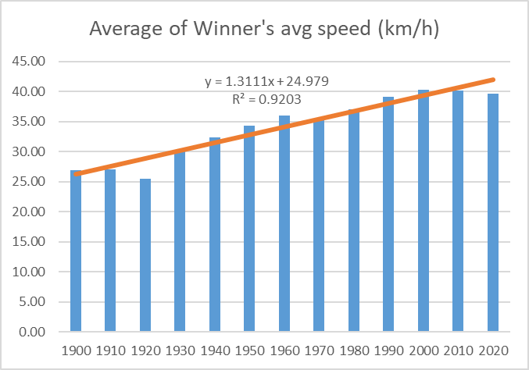 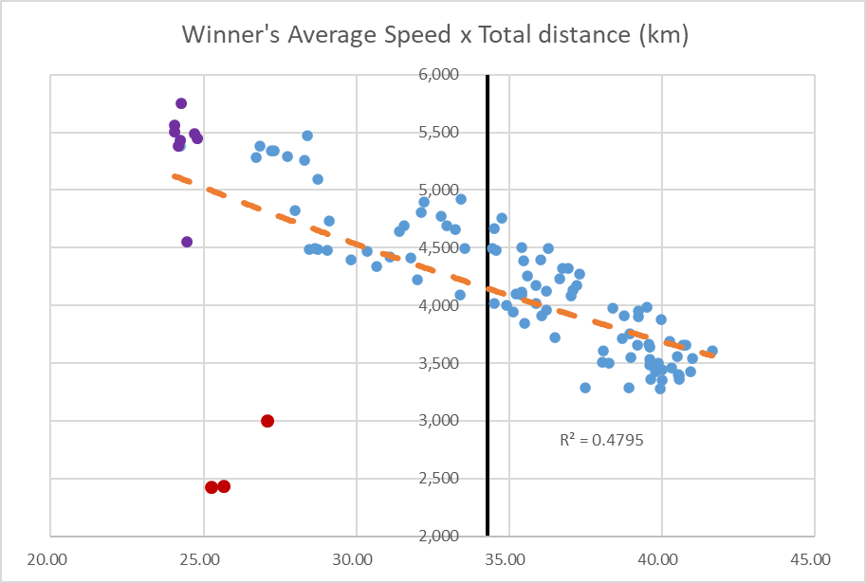

## Linear Regression Statistics

|  |  |  |  |  |
| --- | --- | --- | --- | --- |
| Multiple R | 0.755 |  | The Correlation Coefficient that measures the strength of a linear relationship between two variables. | |
| R Square | 0.570 |  | The Coefficient of Determination, which is used as an indicator of the "goodness-of-fit". It shows how many points fall on the regression line. | |
| Adjusted R Square | 0.5656 |  | The number of independent variable in the model. You will want to use this value instead of R square for multiple regression analysis. | |
| Standard Error | 3.387 |  | Another goodness-of-fit measure that shows the precision of your regression analysis - the smaller the number, the more certain you can be about your regression equation. | |
| Observations | 100 |  |  |  |
|  |  |  |  |  |
| ANOVA |  |  |  |  |
|  | *df* | *SS* | *MS* | *F* |
| Regression | 1 | 1491.571 | 1491.572 | 130.0507 |
| Residual | 98 | 1123.977 | 11.46916 |  |
| Total | 99 | 2615.548 |  |  |
|  |  |  |  |  |
|  | *Coefficients* | *Std Error* | *t Stat* | *P-value* |
| Intercept | 58.64 | 2.184 | 26.84182 | 5.82E-47 |
| 2428 | -0.006 | 0.0005 | -11.404 | 1.12E-19 |

|  |  |  |  |
| --- | --- | --- | --- |
| Equation | y = bx + a | or | y = -0.006 * x + 58.644 |

# Appendix C – Tour de France in Tableau

## Horizontal Bar Chart

This chart illustrates the average of the average speed for each country’s winner over the years. If the reference lines where not present, you could pick out the minimum and maximum average speeds. However, eyeballing the average might not be as easy. Hence the use of multiple reference lines gives you a sense of the countries with riders that are fast!

What other insights would you want to draw from this chart?

## Vertical Bar Chart

The chart illustrates the number of wins per country over the years. The reference line provides you with an average number of wins, which can add the information about the powerhouse countries in cycling. Now for a bonus – Look at both the horizontal and the vertical bar charts and tell me something interesting.

## Stacked Bar Chart

The stacked bar chart extends the standard bar chart from looking at numeric values across one categorical variable to two. Each bar in a standard bar chart is divided into a number of sub-bars stacked end to end, each one corresponding to a level of the second categorical variable. This type of chart can be visualized by the exact count or a percentage of the associated with the second categorical variable.

## Box Plot Chart

A boxplot is a graph that gives you a good indication of how the values in the data are spread out. ... Boxplots are a standardized way of displaying the distribution of data based on a summary of five statistics (“minimum”, first quartile (Q1), median, third quartile (Q3), and “maximum”).

## Line Chart

Here again, the trend is positive (even without a trend-line) but it is very interesting to see how the median average speed holds up to the past and present.

## Scatter Plot Chart

A scatter plot is a chart type that is normally used to observe and visually display the relationship between variables. In this example, if the average distance over a decade is shorter then it doesn’t always equate to an above average speed!

## Dual Axis Chart

A dual axis chart combines a column and line chart and compares two variables. ... A dual axis chart uses two axes to easily illustrate the relationships between two variables with different magnitudes and scales of measurement.

## Geographic Map

Around the world in how many days?

